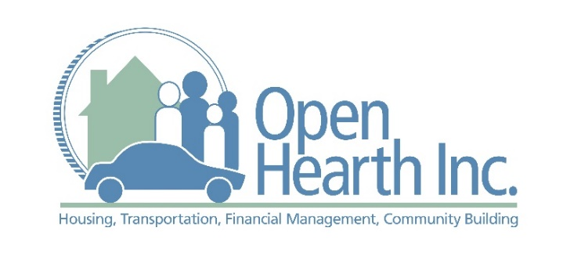
Spring 2020

FREE Personal Financial Workshops

UPDATED ZOOM Workshop Schedule
Open Hearth, Inc. workshops are strictly educational (no product sales). Open Hearth, Inc. is a non-profit organization supporting Chester County residents with housing, transportation, and financial management services since 1991.
Wednesdays | Time | Workshop Topic | Presenter
4/8 | 6:00pm – 8:00pm | Budgeting & Debt Reduction | Financial Coach
4/15 | 6:00pm – 8:00pm | Home Buying Basics | Mortgage Officer
4/22 | 6:00pm – 8:00pm | Good Credit - How to Get It! | Financial Coach
4/29 | 6:00pm – 8:00pm | Finances for a Lifetime | Daily Money Manager
5/6 | 6:00pm – 8:00pm | Car Buying: Put Yourself in the Driver’s Seat | Auto Broker
5/13 | 6:00pm – 8:00pm | Financing Your First Home | Mortgage Officer
5/20 | 6:00pm – 8:00pm | Save Like a Millionaire! | Certified Financial Planner
5/27 | 6:00pm – 8:00pm | Paying for College  (or vocational training) | Financial Aid Officer

REGISTRATION IS REQUIRED
Please register online at www.tinyurl.com/nrec939

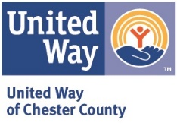
Workshops are offered in partnership with:

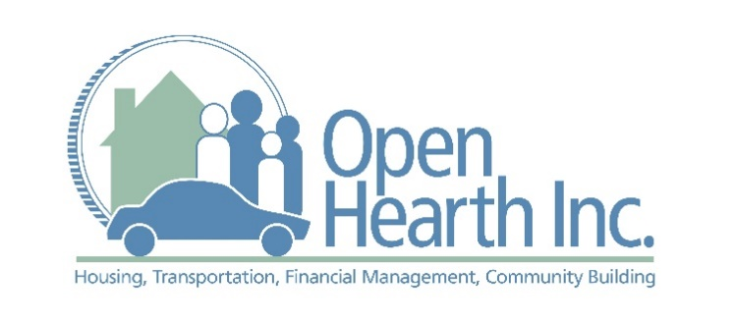
Spring 2020

FREE Personal Financial Workshops

Budgeting & Debt Reduction
Become motivated to create a spending plan that can help reduce your debt and build savings. A plan is also a great stressbuster, leading to better sleep at night! We will talk about the envelope system and other strategies that are easy ways to get started taking control of your money instead of having your money control you.

Car Buying: Put Yourself in the Driver’s Seat
An affordable and reliable car can help ensure long-term financial stability. Purchasing and owning a car, however, can be confusing and expensive. By arming yourself with information, you can find a car that meets your family, transportation, and financial needs. You will learn how to create a car-buying plan that will give you the confidence to make a sound financial decision. You will be guided through each step of the car-buying process by a personal auto shopper.

Finances for a Lifetime
Wish you could afford a Daily Money Manager to answer your financial questions? Bring them to the workshop and your questions will be addressed objectively. Learn how to reduce debt, accumulate assets, save for retirement, and shop for a loan. Learn about wills, insurance, and more! Your questions will be answered in a way you can easily understand.

Financing Your First Home
A mortgage specialist will talk with you about all elements of home financing - including financial readiness to purchase a home - with a focus on credit and mortgage eligibility.

Good Credit—How to Get It!
Learn how the credit system works, how to establish good credit quickly, and fix issues that went wrong. Start designing your personal repayment and repair schedule. You can bring your own credit report to the session to be sure that your personal situation is addressed. A free credit report (without score) is available to you at www.annualcreditreport.com.

Home Buying Basics
Find out how to select and work with a realtor, mortgage officer, and others important in making your dream of homeownership come true! Learn how to find the right home for you and your family, including things to consider about the home’s condition that will influence your initial offer. You’ll also become familiar with the steps leading up to settlement day.

Paying for College (or vocational training)
Explore the cost of schooling and how to finance the education you or your children are interested in, including college or vocational training. An Assistant Director of Financial Aid will explain options including government loans and grants, as well as private scholarships and loans.

Save Like a Millionaire!
Have you heard of the millionaire next door? A certified financial planner will unlock the secrets of successful savers! You’ll learn how to take advantage of the principle of compounding, and how utilizing perks your employer already offers are the keys to building your net worth. Come learn ways to make your money work for you!

Questions? Contact Taryn Alexander:
(610) 280-1033 or TAlexander@openhearthinc.org

